1. Checking for stationarity (ADF & PP) for all the variables:

H0: Has unit root

H1: No unit root

1. fordreturn

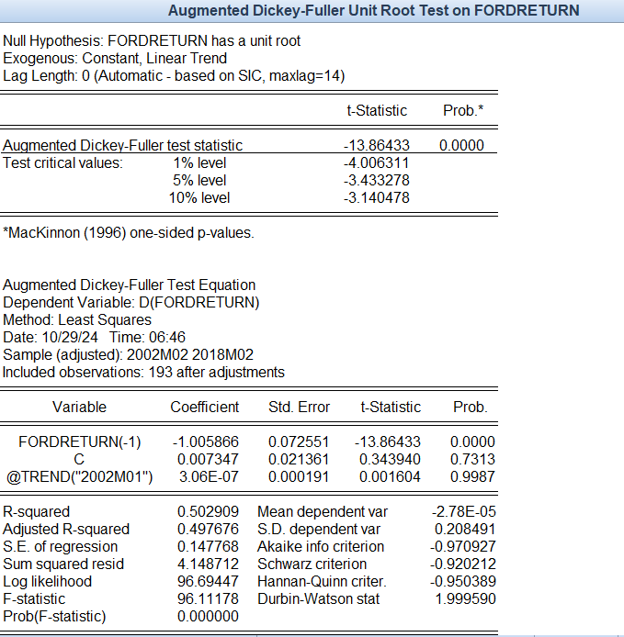

The test show probability of 0.0000 which is less than 0.05, thus we reject the null hypothesis. Therefore, no unit root.

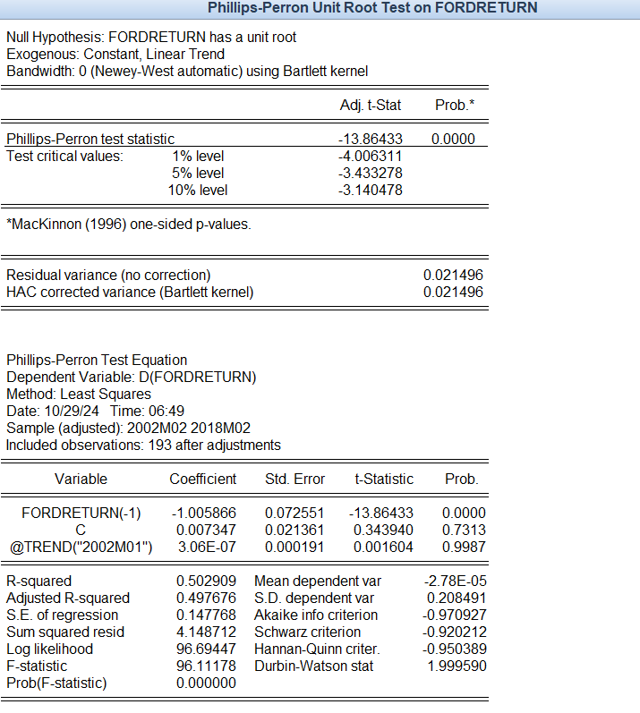

The test show probability of 0.0000 which is less than 0.05, thus we reject the null hypothesis. Therefore, no unit root.

1. snpreturn

The test show probability of 0.0000 which is less than 0.05, thus we reject the null hypothesis. Therefore, no unit root.

The test show probability of 0.0000 which is less than 0.05, thus we reject the null hypothesis. Therefore, no unit root.

1. gs10

The test show probability of 0.1239 which is more than 0.05, thus we fail reject the null hypothesis. Therefore, gs10 has a unit root.

The test show probability of 0.2549 which is more than 0.05, thus we fail reject the null hypothesis. Therefore, gs10 has a unit root.

Since gs10 has an unit root, we treat it with differencing. The stationarity test is done on dgs10, and result as follows.

The test show probability of 0.0000 which is less than 0.05, thus we reject the null hypothesis. Therefore, no unit root.

The test show probability of 0.0000 which is less than 0.05, thus we reject the null hypothesis. Therefore, no unit root.

1. Multiple Linear Regression

R-squared= 0.282947 which means 28.29% of the variation in fordreturn can be explained by snpreturn and dgs10. However, the value is relatively low suggesting that there are other factors influencing fordreturn that are not captured by this model.

One unit increase of snpreturn will increase 1.869505 unit of fordreturn while holding dgs10 constant. The p-value for snpreturn is 0.0000 which is less than 0.05 indicating the relationship between snpreturn and fordreturn as statistically significant.

One unit increase of dgs10 will increase 3.706276 unit of forreturn while holding snpreturn constant. However, the p-value for dgs10 is 0.3913 which is more than 0.05 indicating the relationship between dgs10 and fordreturn as statistically not significant. Thus, dgs10 is not a reliable predictor for fordreturn in this model.

1. Diagnostic testing on model
2. White test (Heteroscedasticity)

H0: Homoscedasticity for residuals.

H1: Heteroscedasticity for residuals.

The white test shows value of 5.980771 and probability of 0.0000 which less than 0.05, thus, we reject the null hypothesis. Therefore, we conclude model do exhibit heteroscedasticity, meaning variance of the residuals changes across observations.

1. Durbin – Watson Stat (Autocorrelation)

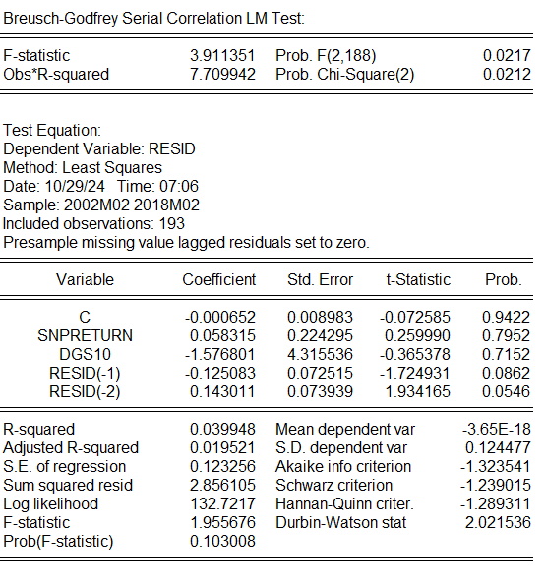

Durbin-Watson stat is 2.021536 which is close to 2, thus suggests no significant autocorrelation in residuals.

1. Variance Inflation Factor – VIF (Multicolinearity)

All the VIF values are below 5, which suggests that multicollinearity is not a major issue in this model.